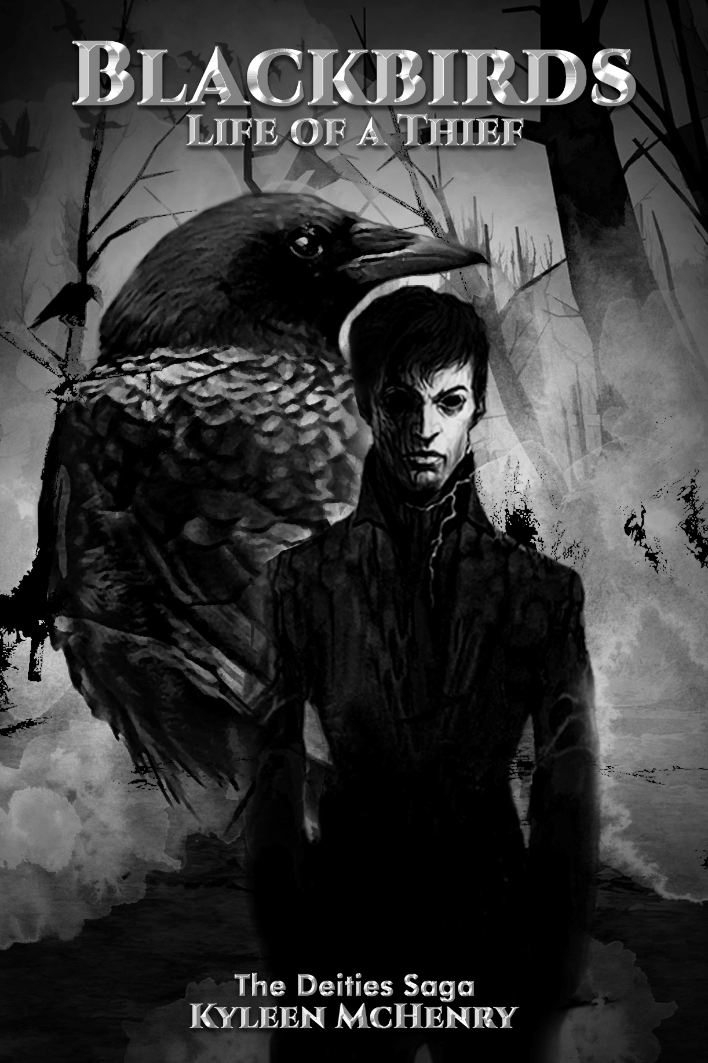

CHAPTER ONE

“It’s probably going to be one of the hottest days in history.” The television was barely audible.
The temperature was way above normal. The heat was so intense, it could melt gold. This summer was the worst since Lonan started living in the tavern’s basement. The basement had no air conditioning, which made it nearly impossible to stay there during the day. Over the last few months, things have been getting stranger than normal.
Stone Creek had experienced unpredictable weather changes, diseases, and unexplainable mass suicides. Due to recent events, Lonan would listen to the local news stations every morning for the past month.
“It has been nearly fourteen days since the last patient died from the Dark Storm. With the disease diminishing, hopefully Stone Creek can rest easy,” a reporter announced.
Lonan’s eyes were getting heavier the longer he listed. He changed the channel before setting the remote down on the table next to him.
“The Dark Storm has brought-” The television was turned off by Mr. Willock, the barkeep.
Lonan gulped before slowly turning around. Willock’s red hair was freshly cut short, and his beard entirely covered his chin. He was wearing a white short-sleeved t-shirt and brown slacks that were torn at the ankles. His biceps were well defined even when they were not flexed, and his six-foot frame allowed him to tower over the five-foot Lonan.
“Why do you listen to that rubbish?” Willock slowly walked behind the bar, looking through the bottles that lined the shelves.
"Like to know what is going on around me," Lonan answered, careful to keep his eyes on Willock.
“What you truly need to know is how to keep this bar afloat.” Willock decided on an open bottle of whiskey; it was nearly half gone from yesterday afternoon. He grabbed a shot glass from beneath the bar. “We are running on little coins and rotted bread. You need to get to work picking them pockets.”
“How am I supposed to do that when the town is all stayin’ in?” Lonan sat on one of the bar stools next to the counter. “Pockets are slim pickins’.”
“You have lock picks and are easily invisible at dusk, with your black hair and dark eyes.” Willock poured himself a shot. “You can simply escape with a coin or three.” He tipped the glass to his lips, draining it in one gulp.
Lonan turned to the side, not wanting Willock to see the fear in his eyes. “I do not want to walk into a home with slit wrists.”
“The more you speak of it, the less time there’s going to be for thieving lad…” Willock poured another glass of whiskey and drank it before continuing. “If you wanna survive, you need to steal." He turned Lonan’s head, so he could look him in the eyes. “You are tall for being only nine. Smarter and faster than most your age as well.” He smirked. “There is nothing to fear.”
“What of the deaths? Or the Dark Storm?” Lonan asked.
Willock held up a hand, “If you want to fear the plague, then fear it. If you want to die of starvation, then starve.” His anger rose with every word. “The gods have no mercy on us; they will never show mercy on you!” Willock took another drink. “Have you learned nothing over the years? You must face your fears!” He took a deep breath, trying to control his temper. “I trained you better than this, don’t let your emotions control you.”
“You speak of not being able to afford food and drink, but look at you?” Lonan gestured at Willock and the whiskey bottle. “I am not going to die just so you can drink!”
Lonan’s eyes stung with the unwanted tears. He felt like he was being taken advantage of and did not know how to fix it. For all of Willock’s speech about courage and strength, that was a fact he could see plainly.
“You are only twenty years older than me, with more strength and speed,” Lonan said. “Why don’t you steal instead?”
“I don’t care how you do it, you little wanker!” Willock threw his glass against the wall. “I am giving you five days! If you don’t do it, you are out of my keep!”
“Aye, aye Captain!” Lonan replied, saluting Willock.
There was no arguing with Willock when he was drinking. His time as a captain for the Provisional Irish Republican Army had hardened his resolve and made him a raging alcoholic.
“I feed you, cloth you, and give you shelter. All I ask in return is help with the bar's upkeep." Willock drank directly from the bottle.

Lonan left the common area of the bar, walking down toward the basement. He grabbed his lockpicks, placing them in his pocket, and backpack loaded with his other supplies. After he was satisfied, he left the tavern, sparing only a glance at Willock, staggering away drunkenly.
Lonan was frustrated by not getting his way. He turned around and glared at the sign in front of the tavern. From the outside, it looked like it had been abandoned for some time; for all of Willock’s talk about maintaining his precious bar, he let it near ruin. The Gods’ Tavern, once the most sought-after establishment, was a joke. He looked at the sign, one nail between it and falling, while the crow insignia was almost unrecognizable. He turned to face the street and started walking; he had work to do and little time to do it.
The tavern was near the forest, Phoenix Park, and a small road led into the main part of the town. Lonan walked along the road, skipping down the hill, towards the town, which was built like one big maze. Buildings were strategically placed to create many alleyways, and most houses looked like one another, which caused visitors to easily get lost.
Unfortunately, with the plague and mysterious suicides that have been taking place, this once overpopulated town now only housed two hundred loyal villagers. Lonan walked by the library, town hall, and the hardware store before coming to the school.
The school was a large building that accommodated all grades from kindergarten to twelfth grade. It was painted brown, with white letters reading 'Stone Creek Primary School'. The playground was fenced off, along the side of the building, and only the elementary school aged children had access to it.
Lonan placed his hand on the playground’s fence. "Man, I hated this place.” He sighed.
During the school year, Lonan was teased about not having parents. The words would sting, and he could not help feeling abandoned. He would get hit by the bullies and would come home with bruises and black eyes. One day, Willock started teaching him martial arts, to defend himself. After the bullies received a few broken noses they stopped tormenting him.
Lonan let go of the fence and continued to walk, peering through the alleyways, and carefully looked through some open windows. Slim pickings indeed, he thought. His stomach began to rumble, his hunger was worsening. He knew that he could not return to the tavern without some coins in his pocket, so he headed to the food market in hopes that he could find something of use.
The food market was the only tempting target that Lonan was not afraid to break into. It was run by Mr. Jensen, an old man whose bad temper, and dislike of children, made him Lonan's favorite target.
He scoped the area before looking at the locks. “Even in this blasted plague, that old fool still changes the locks often.”
He looked for another way to enter. The windows that were normally open at this hour were closed. Peering into the distance, trying to be careful not to be noticed, he walked to the back of the building. After several minutes, he decided that climbing the ladder at the back of the building might be the easiest way to break in. After walking back around the building to make sure no one was watching, Lonan climbed up the ladder.

